Using Mediasite Desktop Recorder for Screen Recording

- Log in to Mymediasite https://mediasite.umaryland.edu/mediasite/mymediasite
- Login with your UMID and password.
- Click on Add Media.
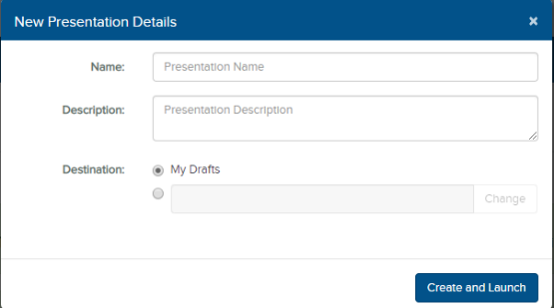
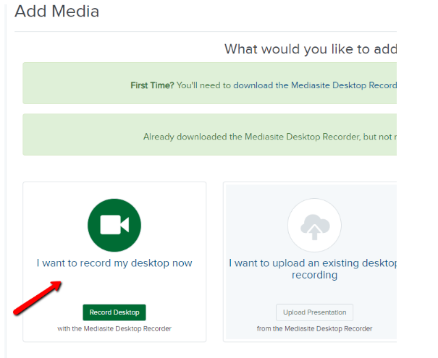
- Click on “I want to record on my desktop”
- Add a name to your Presentation.
- Click ”Create and Launch”.
- Click on “mdr” to open the recorder. Follow directions. Mymediasite Desktop Recorder window will open.
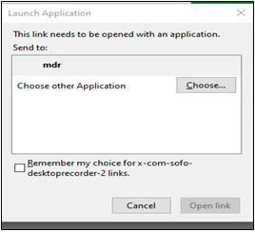

- Click on “Record”.

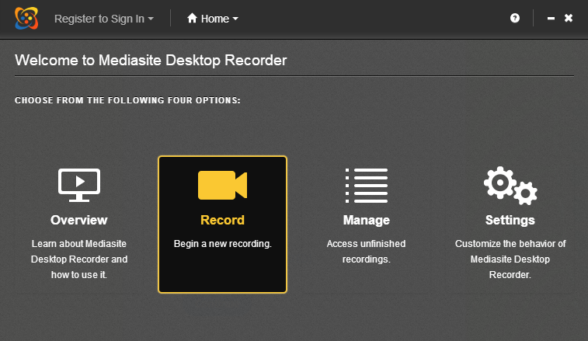
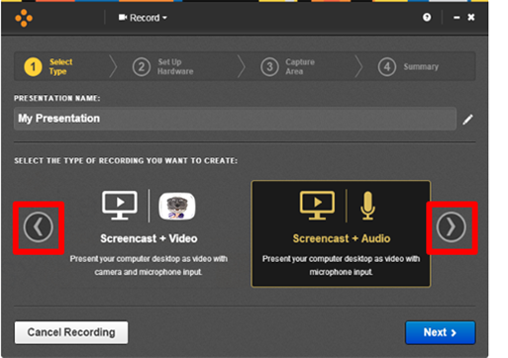
- Choose “Screencast + Audio” for a PowerPoint voiceover or “Screencast + Video” for audio and video recording.
- Verify Presentation Name or make changes the click “Next”.
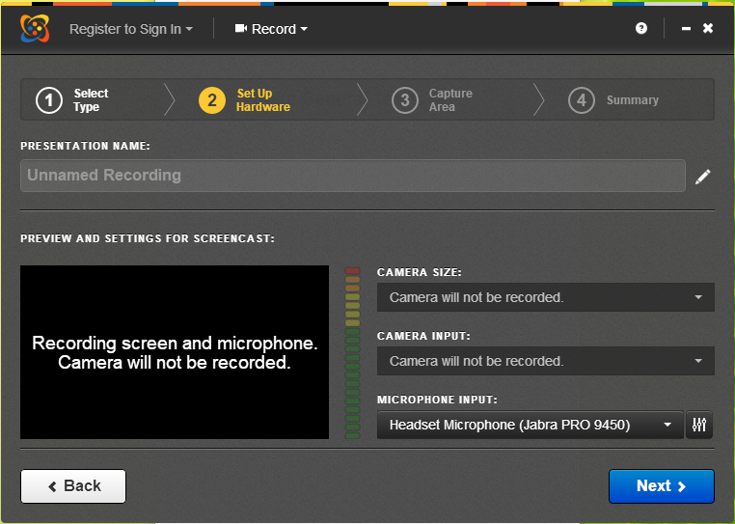
- Choose the desktop you wish to record. You will see a red box around the
selected desktop.
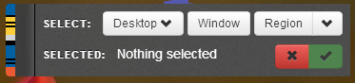
- Recommendation is 1280x720. Select your camera and mic inputs.
- You can start recording.
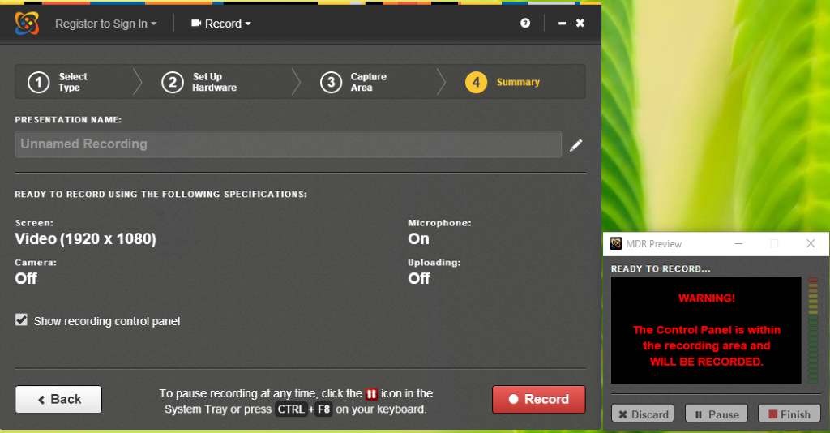
- Once you are finished recording a “Recording Management” window will open.
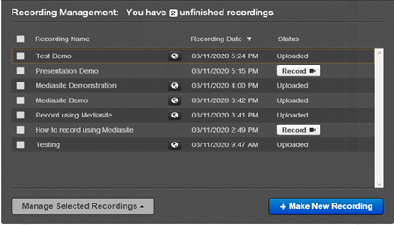
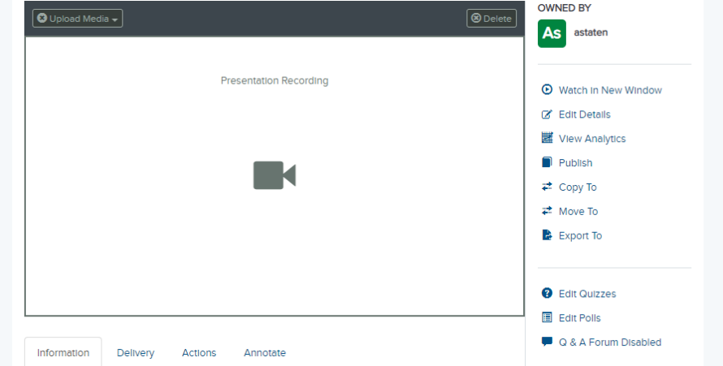
- Click on the globe icon next to recording name.
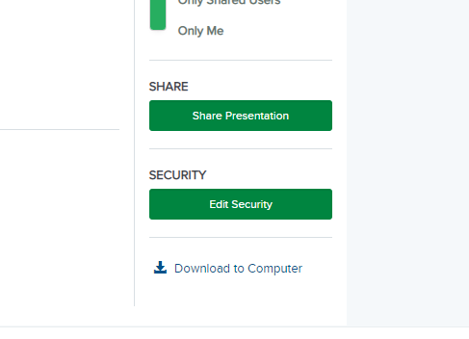
- Scroll down to “Share Presentation” in the green box and click.
- Click on “Copy” in the green box, to paste the link to the recording.
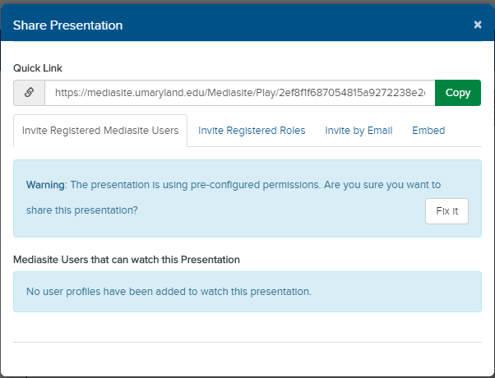
- Close the window.
- Click Watch in New Window to view your recording.
- Your recording automatically publishes to your mymediasite area.

