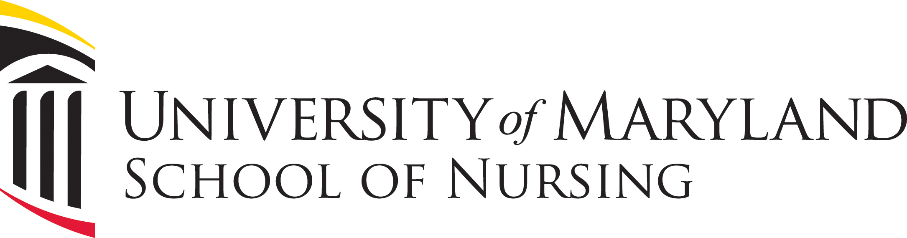

Class of 1964 - 50th Reunion

Class Dinner Reservation Form

The UMSON Class of 1964 will hold a 50th Reunion Class Dinner on Saturday, April 26, 2014. The dinner will take place at the Hilton Hotel, 401 W. Pratt Street, Baltimore, MD 21201, located just two blocks from campus.

Spouses and guests are more than welcome to attend. Each person will be responsible for their own check.

To help with planning, please indicate below if you plan to attend the dinner and if you will bring a guest. Please return this form in the enclosed business reply envelope by March 26, 2014.

I will_____ I will not_____ attend our 50th reunion Class Dinner on Saturday, April 26, 2014.

I will bring a guest. Guest name: __________________________________________________

Name: ________________________________________________________________________

Address: ______________________________________________________________________

______________________________________________________________________________

Home Phone: ______________________________

Cell Phone: ________________________________

Email: ________________________________________________________________________

Thank you! We look forward to seeing you on April 26!

