BEFORE YOU START: Please note that new information cannot be entered directly into Biography and Expertise dropdowns – these details must be entered into the appropriate Faculty Success (formely Digitial Measures) screen FIRST (details follow).
Also, any changes you make in FS will appear in the web directory the following day.
The SON Web Directory is populated through Faculty Success (formely Digitial Measures). Your name, title, department, campus address, phone number, and credentials will automatically display in the web directory as they appear in Faculty Success (formely Digitial Measures)..
However, any other information that you wish to appear on your faculty profile in the Web Directory must be added by YOU. Please read ALL of these instructions before you begin.
1: To add information, log in to Faculty Success (formely Digitial Measures) and select the Biography and Expertise screen:

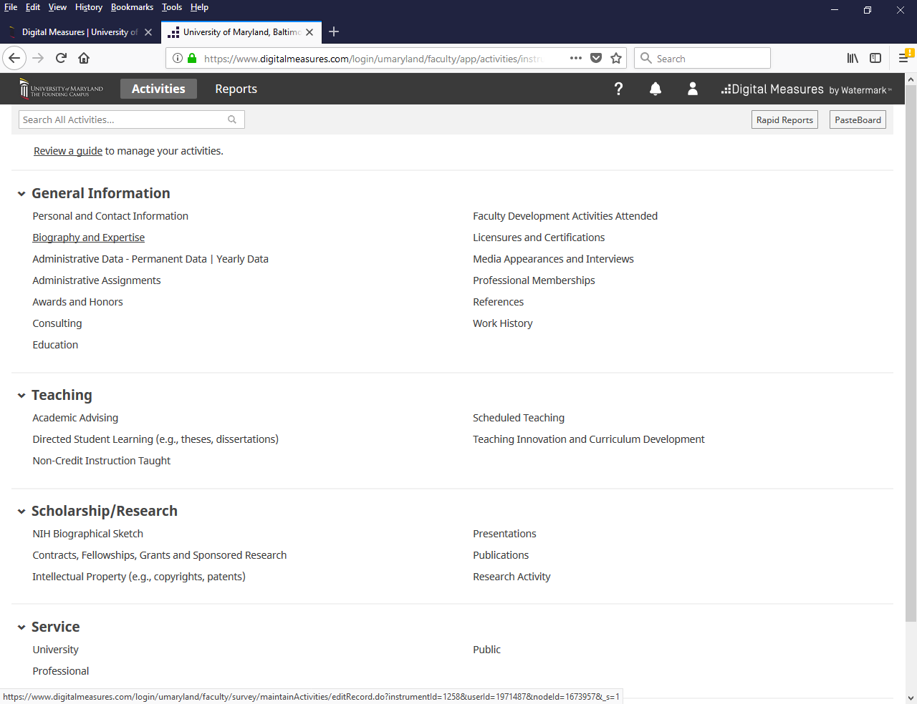

PLEASE NOTE AGAIN: New information cannot be entered directly into Biography and Expertise dropdowns – these details must be entered into the appropriate Faculty Success (formely Digitial Measures) screen FIRST.

2. Once you are in the Biography and Expertise screen, you’ll notice a couple of things at the top of the page. If your profile does not read Yes after ‘Include in Web Directory’, then you don’t need to fill out any other information. You can still populate this screen if you wish, since you will be able to pull elements of Biography and Expertise into your CV should you so choose.

Directly below that you’ll see your credentials listed. If these are incorrect, please contact the Office of Communications to request any changes.
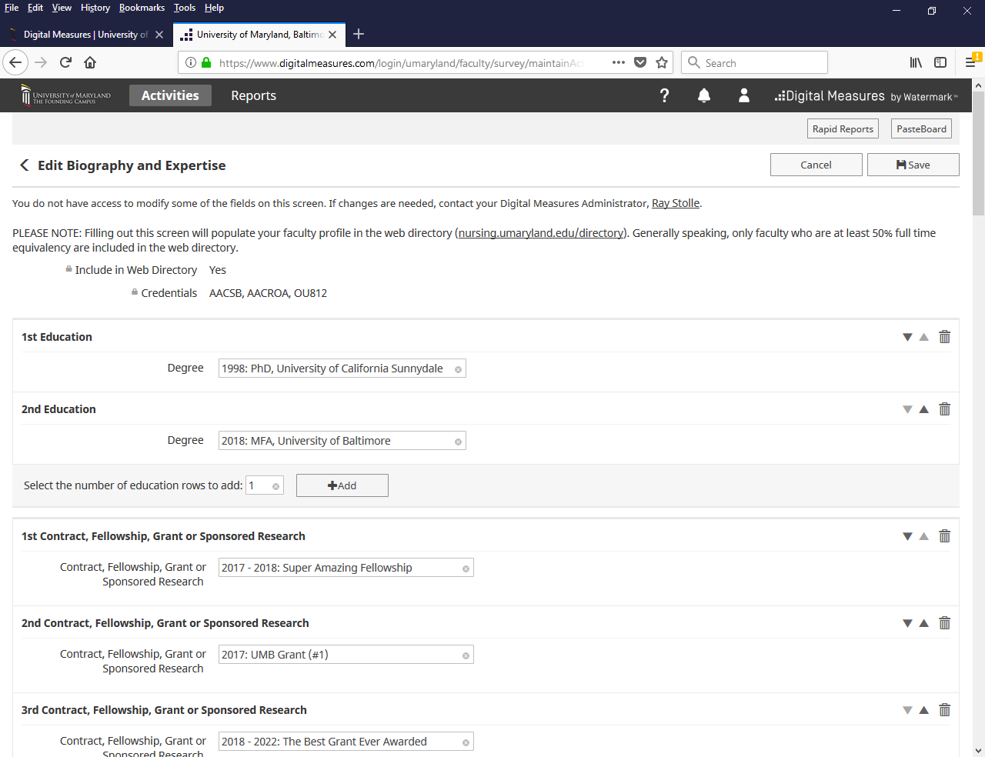

3. After credentials, directory items appear in the order in which they will be listed in the Web Directory:
- Education
- Contracts, Fellowships, Grants and Sponsored Research
- Research Interests (text box)
- Research Activity
- Link to a full list of your public work (text box)
- Publications
- Presentations
- Areas of Specialization (text box)
- Primary Teaching Areas (text box)
- Award and Honor
- Professional Memberships
- Academic and Professional Activities – University
- Academic and Professional Activities – Professional
- Academic and Professional Activities – Public

Items above in blue are text boxes – you can enter directly into these fields only. All other items are dropdown boxes; data must first be added to the appropriate FS screen before such information will appear in the dropdown boxes.

4. Following these items, beginning with ‘Brief Biography’, there are additional fields in the Biography and Expertise screen which you can populate if you like, but which will NOT be displayed in the Web Directory (again, these can be used when building your CV).

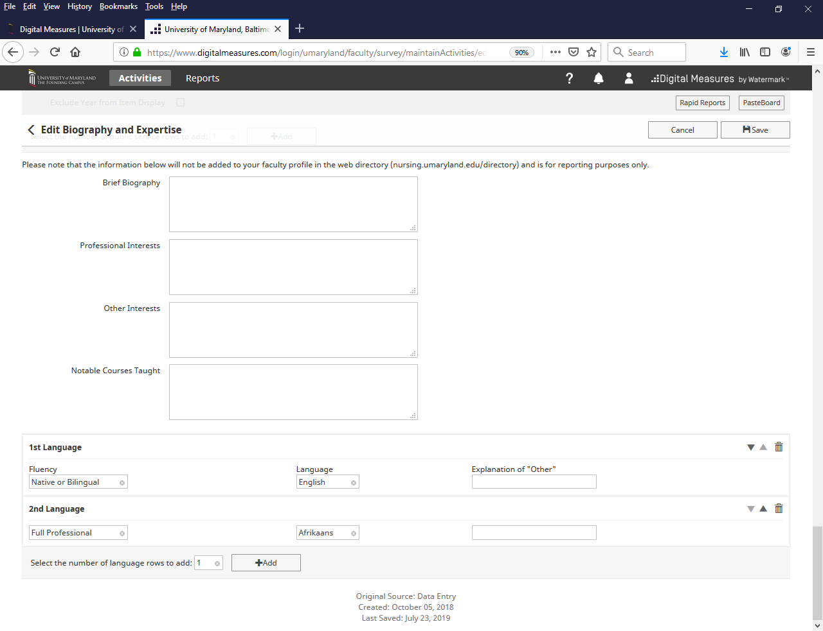

5. IMPORTANT: Entering New Items from Dropdown Menus
When adding and entering new items from dropdown lists, please keep in mind that you MUST have already entered the item in question into its proper FS screen beforehand. You cannot enter NEW dropdown items into FS directly via the Biography and Expertise screen.
For example - Maggie has three items already listed as Contracts, Grants, Fellowship, and Sponsored Research for her Web Profile in the Biography and Expertise screen:
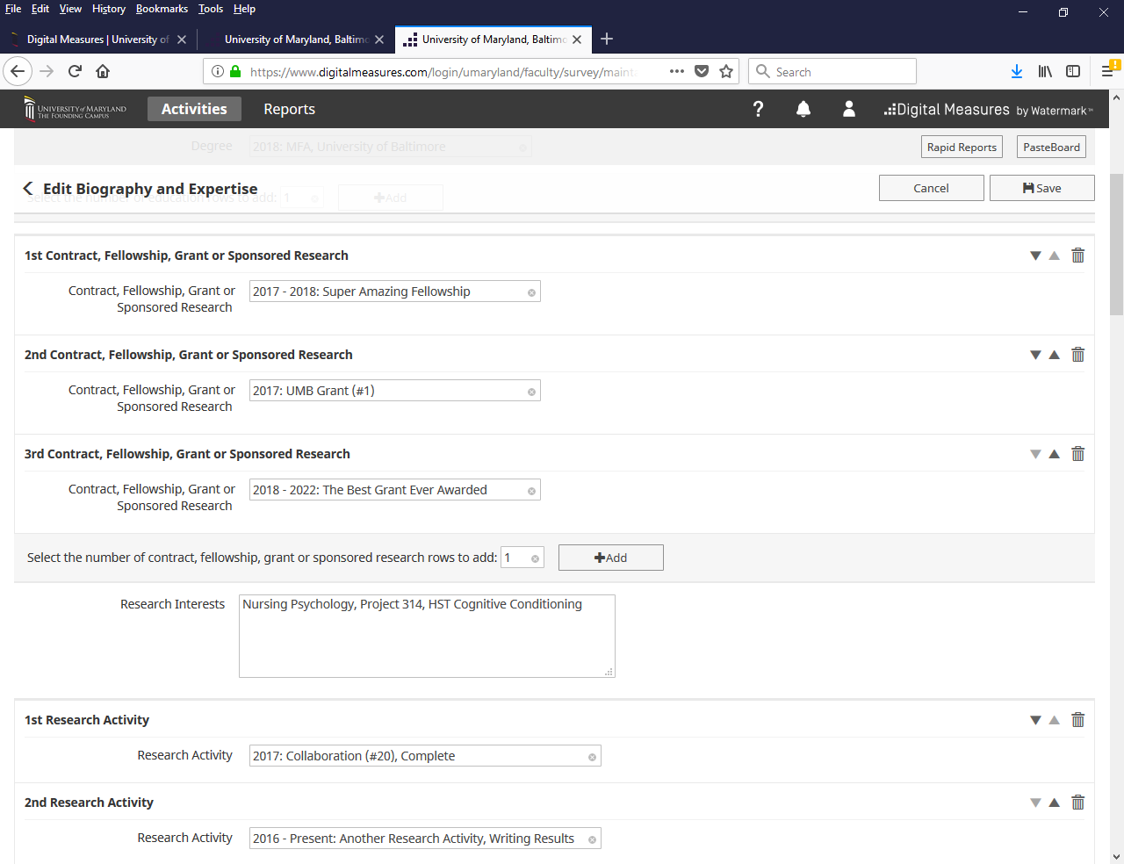
However, she wants to add a fourth item here. To do that, she’ll select the +Add button (indicated above).

6. When the +Add button is clicked, a space will appear that will allow you to select a new item from a dropdown (see below). Maggie will select the Really Important Research Project, and then hit the Save button in the upper right hand corner. Note that this item would NOT have appeared as one of the dropdown selections if Maggie hadn’t already entered it into the Contracts, Fellowships, Grants, and Sponsored Research screen.

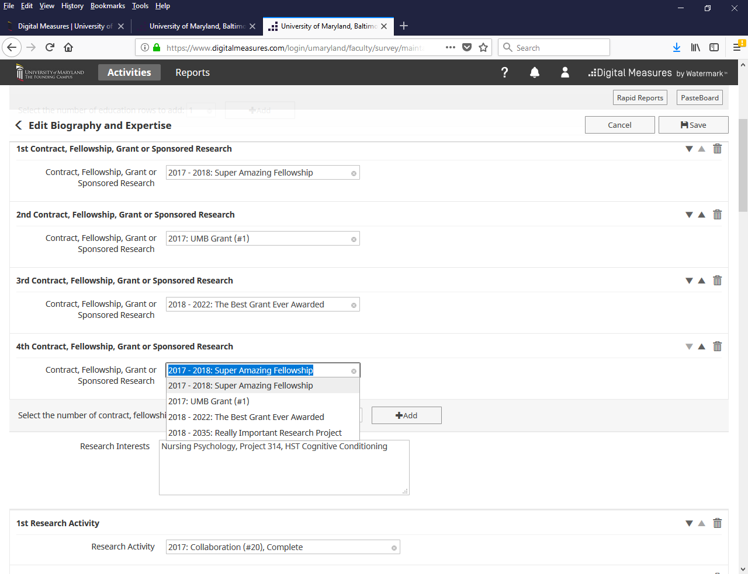

7. After hitting ‘Save’ and going back into the Biography and Expertise screen, we can see that Maggie’s new grant has been added. And by using the up/down arrows and trashcan icons to the right, Maggie can reorder or delete each individual entry within each section.
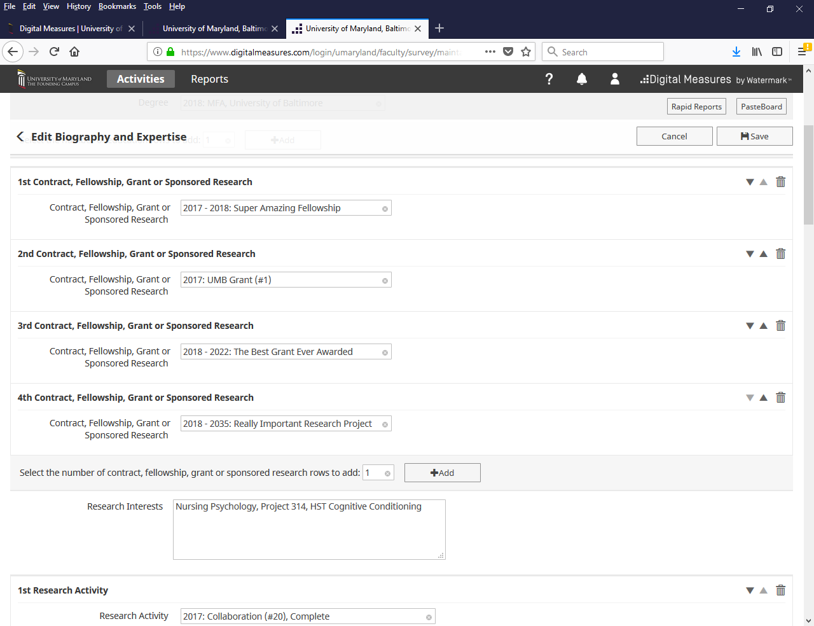
Reminder: In areas where you can make selections from dropdown menus in the Biography and Expertise screen, you are limited to a maximum of 10 entries in each section.
Any changes you make in FS will appear in the web directory the following day.

